The below example is a table taken from a Mintel report and includes, at a glance, a range of information indicating the quality and usefulness of the source.
Check the dates. Tables may include data from older sources and this might not always be clear, especially if it is research being reported in a book or news article.

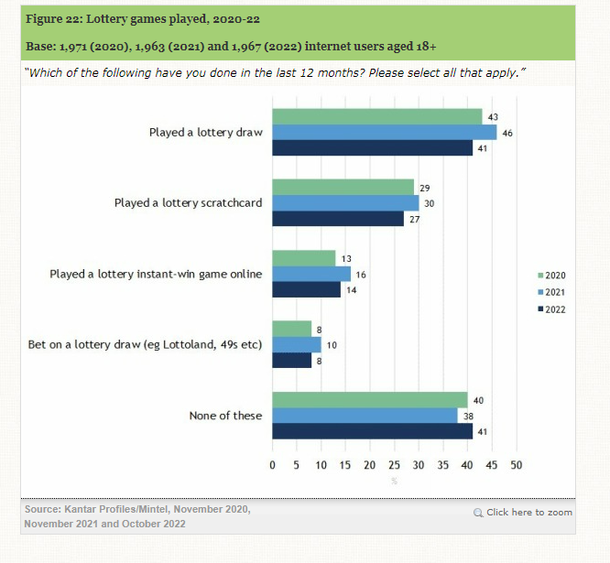

This graph also includes the ‘population’ surveyed which may or may not fit your criteria. Extra information on this or full tables of raw data may be available later in the report or its appendices.
Number of respondents is key when judging how useful any figures are. If the number is very low it might be harder to draw valid and reliable conclusions from the data.

The source of the data is very important. Kantar and Mintel are both independent and respected Market Research companies. Government departments, professional bodies etc. might also be a good indicator of unbiased data.

Mintel (2023) Lotteries – UK – 2023: Consumer: Lottery Play [Online]. Available from: https://reports.mintel.com/display/1173537/ [Accessed 30 January 2023].
When, who, what and how - Look for:
- When was the data collected (are the dates appropriate to you research?).
- Who gathered the data (what is the source of the data. Sometimes this will not be those publishing it, for example an independent company or official statistics may be used. You might also consider asking what the purpose of the data/research is).
- How the data was gathered (anything about methodology; e.g. number of respondents & who they are, the question asked, the approach taken). Mintel, for example, publish their methodology here.

If you have concerns, look further (Raw data in appendices, the original report or research, references etc.).
For example, you might question the purpose of the below data and whether this raises a question of quality. It is presented in a TUC report advocating a minimum wage.
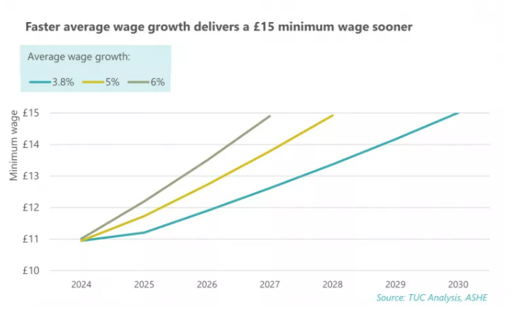

The TUC is likely to be considered a reputable source but you may not know where the data itself comes from. They note that this is their own analysis.

TUC (2020) Raising Pay for Everyone: a plan for high wage economy and a £15 minimum wage [Online]. Available from: https://www.tuc.org.uk/sites/default/files/2022-08/raisingpayforeveryone1.pdf [Accessed 30 January 2023].
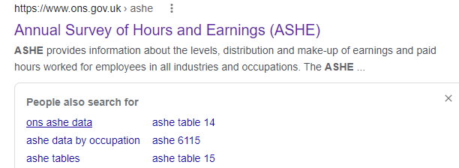

A quick search for ‘ASHE data’ reveals that it is the “Annual Survey of Hours and Earnings” and is an ONS (Office for National Statistics) publication. As official statistics (.gov.uk) this is likely to be considered a good source.

The full ASHE report raw data is available via the ONS website. You could check this for consistency (it may also be useful for your research).

Some questions remain (e.g. which year of the ASHE survey? what methodology did the TUC use?) but still this could be considered a good source. As with most types of resource, good reports will usually reference their sources fully.

