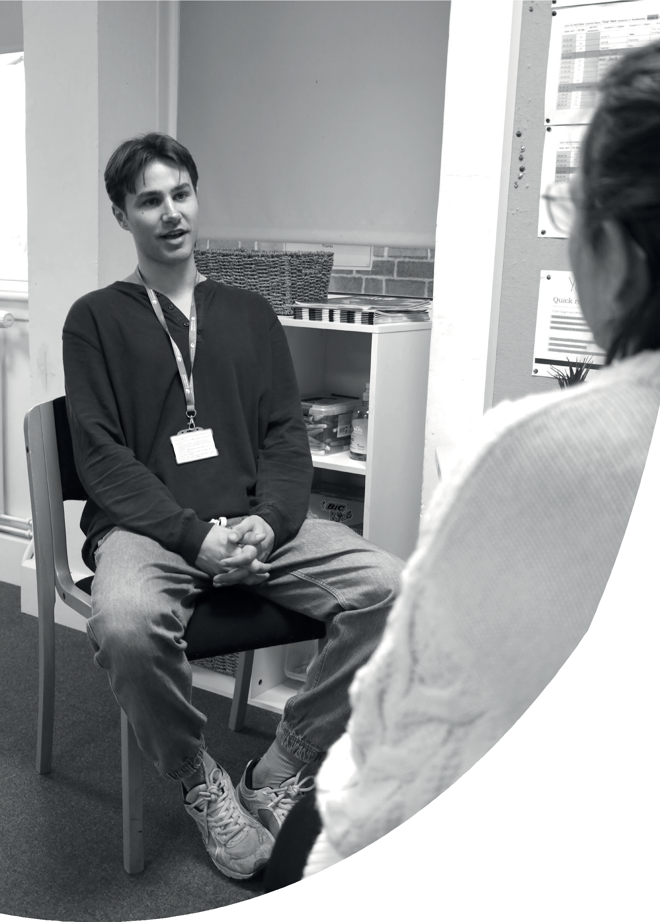

Course Handbook

Counselling

BA (Hons) Counselling & Psychotherapy/Dip.HE in Person-Centred Counselling: 2025-26

Welcome to your course, BA (Hons) Counselling and Psychotherapy and Diploma of Higher Education in Person Centred Counselling at University Centre Colchester (UCC).

Person Centred Counselling has over twenty-five years of experience at the University Centre Colchester. The first two years (the Diploma in Higher Education) are British Association for Counselling & Psychotherapy (BACP) accredited from which graduates can develop their own practices or follow careers of further study or within the NHS/organisations focused on the psychological wellbeing of others.

This course is part of UCC’s academic provision, which covers three key areas of the employment market: The Arts, Social Sciences, and Industry.

You have chosen this programme because of the skills and interests you have developed before starting a degree-level course, and because the course content on offer at UCC will develop you as a future practitioner in your field.

We hope you enjoy your course and being part of the student community.

For further information about course philosophy and delivery, please see

<https://www.colchester.ac.uk/course/ba-hons-counselling-psychotherapy/>

1. **Your course team.**

Your course team consists of academic, administrative, and technical staff, who between them have a wealth of experience and expertise. The following list of staff are the key points of contact for this course.

|  |  |  |  |  |
| --- | --- | --- | --- | --- |
| Name | Job title | Rm. | Tel. | Email |
| Simon Drane | (Acting) Area Head Health and Social Care and Science | S408 | 01206 712491 | [Simon.drane@colchester.ac.uk](mailto:Simon.drane@colchester.ac.uk) |
| Lindsay Horsley | Assistant Area Head: Counselling & Psychotherapy | K451 | 01206 712300 | [Lindsay.Horsley@colchester.ac.uk](http://www.colchester.ac.uk/ucc/partnerships) |
| Chloe McIntyre | Lecturer  Module Lead | K451 | 01206 712222 | [Chloe.McIntyre@colchester.ac.uk](https://www.bacp.co.uk/search/Courses) |
| Kelly Rothery | Lecturer  Module Lead | K451 | 01206 712000 | [Kelly.rothery@colchester.ac.uk](mailto:Kelly.rothery@colchester.ac.uk) |
| Frances  Whiteman | Lecturer  Module Lead | K451 | 01206 712009 | [Frances.whiteman@colchester.ac.uk](http://www.officeforstudents.org.uk) |
| Sam  Watson | CICS co-ordinator | K452 | 01206 712184 | [Sam.watson@colchester.ac.uk](http://www.qaa.ac.uk)  [CICS.info@colchester.ac.uk](mailto:CICS.info@colchester.ac.uk) |
| Justyna Matejek | Group Facilitator |  |  | [Justyna.matejek@colchester.ac.uk](mailto:Justyna.matejek@colchester.ac.uk) |

In addition to the above staff, you might also meet visiting lecturers and in-house supervisors whose experience within the counselling profession provides an important, and highly valued, contribution to your course.

**UCC Academic Services** provide you with student support and guidance in relation to the following:

Submissions and uploading of work

Extenuating circumstances/late submission of work

Financial hardship

Accessibility/assessment for reasonable adjustments and learning support

Contact names for UCC Academic Services:

Chris Mills: Head of UCC Academic Services: Room HE107

Tracy Blair: Senior Academic Services Officer: Room HE107

Natasha Sayers: Academic Services Officer and administration support for Counselling programme. HE 105

Contact no. 01206 712613

Email: [UCCacademicservices@colchester.uk](mailto:UCCacademicservices@colchester.uk)

1. **Your course**

This course addresses the importance of mental wellbeing that is rapidly reaching the forefront of the Government’s health agenda. A clear distinction between physical and mental health is giving way to a more holistic view. Consequently, talking therapies are increasing in popularity, with more trained counsellors and psychotherapists needed to meet the demands of an increasingly health-conscious society.

The structure and content of your course are set out in documents that can be found in the appendix to this handbook.

**Module Guides** (appendix A) are the reference documents that have the schedule of lectures for each module. You can also see what the course work requirements are, and how your work will be marked.

The programme specification is an overarching document that itemises course structure and content, and most importantly, what you should be able to do by the end of the course. All programme specifications, including the module descriptors, are available on request from UCC Academic Services.

All learning outcomes are written in such a way that they conform to the expectations set out in the <https://www.qaa.ac.uk/the-quality-code/qualifications-frameworks> which in turn ensures that the learning outcomes for your course are equivalent to those of similar programmes in other universities and colleges in the UK.

The design of this programme has been shaped by the national subject benchmark for Counselling and Psychotherapy <https://www.qaa.ac.uk/docs/qaa/sbs/sbs-counselling-and-psychotherapy-22.pdf?sfvrsn=73b3dc81_2> . A benchmark describes the characteristics of a subject, and the abilities and skills students develop when studying a subject. Benchmark statements are written by panels of national experts and revised regularly. An introduction to subject benchmarks can be found here:

[https://www.qaa.ac.uk/the-quality-code/subject-benchmark-statements/counselling-and-psychotherapy#](https://www.qaa.ac.uk/the-quality-code/subject-benchmark-statements/counselling-and-psychotherapy)

To ensure that courses develop a wide range of skills, UCC designs programmes in each subject by also taking subject benchmark statements of other disciplines into consideration. For example, the element of communication is a vital component in your skill development, and we have taken note of the subject benchmark statements of other Arts, Social Sciences and Industry programmes that also promote the development of communication skills.

1. **Teaching, Learning and Assessment**

**Teaching and Learning**

UCC offers a blended approach to teaching and learning. Counselling training at UCC is predominantly on-site and conducted in-person. As a BACP Accredited course, we have embedded the BACP Online & Phone Therapy (OPT) curriculum within the course. The BACP states that some teaching and learning needs to be online to reflect OPT but no more than 30%. In practice this represents 2 full days in years one and two. When attending learning online we request you are aware of “online etiquette” required for this element of the training. This will include having a suitability designated private space

**Assessment**

Course work across all programmes at UCC can consist of different forms of assessment, ranging from essay or presentation-based submissions to live performances, exhibitions, and edited video material, amongst others. We positively welcome and encourage alternative forms of assessment, which are linked to the specific requirements of a subject area.

All assessments are carried out according to the information set out in the relevant module guides. Please see appendix A for further details.

Most Schools in UCC use the Harvard Referencing System <https://portal.colchester.ac.uk/support_departments/ssandsupport/LearningResourcesandStudent/Colchester_Institute_Library/Harvard/Documents/Guide%20to%20Harvard%20referencing.pdf>

In addition to the information given out by the lecturing team, Colchester Institute library also offers advice sessions for students on how to use citation guidelines.

Our Counselling Librarian and Learning Resources Advisor is [tracey.white@colchester.ac.uk](mailto:tracey.white@colchester.ac.uk) Tracey is based in the library and available to respond to specific enquiries.

If any part of your research work requires ethical approval, you will be guided by the course module lead in applying for permission. If you are not sure whether this might apply to one of your forthcoming submissions, please speak to your module or personal tutor.

**Placements and work-based learning**

This course includes placement or work-based learning.

A placement or work-based learning situation is part of Personal and Professional Development 3 and Personal and Professional Development 4, which students undertake in second and third years of the course. It involves completion of a minimum of 100 of counselling practice hours with real clients supported by the Colchester Institute Counselling Service (CICS) and its dedicated co-ordinator.

Student counsellor handbook can be accessed … <https://moodle.ccacolchester.com/course/view.php?id=6689>

**Study Skills**

UCC has a suite of study skills videos and presentations that can be located on Moodle**.**

[**https://moodle.ccacolchester.com/course/view.php?id=6689&section=1**](https://moodle.ccacolchester.com/course/view.php?id=6689&section=1)

**Submitting course work**

All submission of course work must follow the arrangements set out in the respective module guides.

You must submit all pieces of assessment needed for each module on or before the submission date published in the module guide. Failure to do so is highly likely to result in failure of the module overall and may put your place on the course at risk.

Please remember that it is your responsibility to meet the given submission dates, and that only very specific, and documented, situations for exemptions are acceptable to UCC. These can be found in the Extenuating Circumstances policy:

[University of East Anglia Extenuating Circumstances Regulations - Colchester Institute](https://www.colchester.ac.uk/legal/university-of-east-anglia-extenuating-circumstances-regulations/)

**Guidance on Coursework Submission Requirements**

**Written Submissions and Word Targets**

A word target, or equivalent, will be specified for all written assignments. Students must declare the actual word count at the end of the submission. Assignments may not be marked where an actual word count is not clearly indicated.

Please note, the following contents of a written document are excluded from the word count:

* + cover page.
  + abstract (except undergraduate dissertation abstracts, which are included)
  + contents page
  + headers and footers
  + headings of charts
  + appendices
  + reference list

The following are included in the word count:

* + citations (including ‘indented quotes’) and in text referencing
  + footnotes and/or endnotes
  + words contained within tables

The following features should be applied to ensure the marker can read written assignments clearly:

* + Font style: Ariel, Calibri or New Times Roman
  + Font size: 11/12
  + Line spacing: 1.5
  + Page numbers (in footer)

The following information should be included to identify whose assignment it is and what module it relates to: (in header)

* + Module title
  + Module code
  + Student number (work should be anonymised)

Appendices and footnotes/endnotes should only include material which markers are not required to read, but to which they may refer if they wish. Appendices therefore include information which supports the assignment, such as, for example, data sheets and anonymised survey feedback. Appendices must not be used as a device for extending the main text. Quotes from secondary sources can be used to illustrate or support the points of your assignments although you should indicate an awareness of the secondary source’s status. Direct citations should not make up more than 10% of your total word count.

Students may submit assignments with a variation of the required word target by plus or minus 10% without incurring any penalty.

A specified word target serves two purposes. Firstly, the upper end of the available word count range requires a writer to be selective in the information included and concise in the way it is presented. Secondly, the lower end of the word count range is indicative of the detail required to respond satisfactorily to the assignment task.

Should an assignment fall outside the permitted variables of the specified word target, the marker will be required to deduct 3 percentage points from the mark awarded. (e.g. a mark of 50% will be reduced to 47%).

Should the 3% reduction of a mark result in the assignment’s mark being below 40%, the penalty will be capped at 40%.

**Formative and Summative Feedback**

Tutor feedback about your work falls into two distinct categories. The first is weekly, ongoing feedback that is part of the teaching process. Your lecturers will invite contributions to the taught sessions by asking you questions, or seeking group feedback from the class, which in turn leads to a tutor’s response to your comments or contributions. It is called formative feedback because of the immediate, and non-assessed, nature of an exchange of views, which nevertheless contributes to your studies.

In addition to formative feedback in class, individual tutorials (2x20 minutes) are available to you for each module. You will need to arrange these with your tutor.

The second type of feedback you receive is called summative feedback. It is usually associated with marks given to a formally submitted piece of course work. Summative marks are used decide the grade you receive for a module. Written feedback reflects how you have met the learning outcomes and includes feed forward on how you might develop your work from a counselling training and/or academic perspective.

It’s worth remembering that summative assessments will still have a formative effect on your development, because each piece of work you complete contributes to your overall achievements as a student.

**Pastoral Tutorials**

You will have the opportunity to meet with your pastoral tutor for 30 minutes per semester. This is timetabled and you will be offered a date/time to attend.

**Academic integrity**

The term ‘academic integrity’ can cover a range of issues in connection with the use of the work of others. For you as a student, this is particularly relevant as much of your time is spent encountering the published thoughts of others.

What that means in practical terms is that you must always show the sources of the material you are using. From a literal quotation to the adapting of an idea, it is vital that other authors are always referenced. The part of a submission that is not linked to someone else’s work is therefore seen as your own contribution.

All universities use software that detects what may have been copied from a non-disclosed source. This practice is called a plagiarism check. **Plagiarism is a serious academic offence which can lead to course work being failed and, in some circumstances, students losing their place on a course.**

It is therefore essential that students act responsibly, and with academic integrity, by always showing their sources.

Other examples of breaches of academic integrity include the copying from peers, collusion, the use of commissioned course work from third parties, or any attempt to pass off the work of others as your own.

University Centre Colchester’s policy on academic integrity can be found here in the <https://www.colchester.ac.uk/legal/ucc-academic-offences-policy/>

policy.

It is worth noting this policy also relates to the use of AI and states –

**USE OF ARTIFICIAL INTELLIGENCE SOFTWARE**

1.3 Students are permitted to use artificial intelligence software to help them understand material and how that can be expressed but are not allowed to use that software to complete the assessment (or any part of it) for them. If a student uses artificial intelligence software to complete work for them that will be plagiarism under criteria a, c or d as shown above. Students should consider use of artificial intelligence software as a research tool only, and they should ensure that they cite its use by inserting a footnote or endnote which acknowledges that they used such software and what it helped with.

**External Examiners**

Each course has an external examiner, usually an academic or highly experienced practitioner in their field, whose role it is to ensure that the standards of your programme are comparable to those found at other UK institutions offering similar courses.

The list for UCC’s external examiners is available from UCC Academic Services upon request.

1. **Communication**

All tutors, administrative and technical staff communicate with you via your colchester.ac email account. It is your responsibility to ensure the account is working, and that you check emails regularly.

UCC will not accept any liability arising because of students not maintaining, or checking, their colchester.ac email account.

Written feedback to course work will be uploaded on Moodle within the time scale specified.

Students are expected to communicate with tutors, administrators, and technical staff via their colchester.ac email accounts.

Email etiquette is an important element of working together. Please note that some staff may not be available every weekday. The colchester.ac.uk email signatures are likely to show on which days your tutors are available.

1. **Extra Costs**

This course does not include the purchase of any specialist equipment, visits, field trips, clothing, or consumables which students must buy whilst completing the programme. Field trips are encouraged but considered optional.

Students must purchase a Dictaphone or similar recording device to record role play practice and client work in preparation for supervision. The cost is approximately £40.

Students must also undertake and evidence personal therapy sessions consisting of a minimum of 5 meetings per semester with a counsellor of your own choosing at a cost of between £30-50 per session.

Other added costs are (as of 2024):

£44 for the Enhanced Disclosure and Barring Service check

£82 (although reductions are available dependant on personal circumstances) for BACP membership

£50 + for personal indemnity insurance for counselling practice.

Year two (optional) trip to the Freud Museum and/or Bethlem Museum in Kent (Approx £25 plus travel)

£15 for a small clock for use in counselling rooms.

The course team supplies advice and support relating to the additional costs.

1. **Support and Guidance**

At the beginning of each academic year, you will be assigned a personal tutor who may or may not be part of the course team that teaches you.

The personal tutor is your first point of contact for all non-academic concerns. You are entitled to a personal tutorial of up to 30 minutes per semester. Personal tutorials are timetabled and might also be initiated by you as and when the need arises.

UCC has teamed up with **Health Assured** to provide all UCC students access to a **Student Assistance Programme**. See link for further information. [Section: Assistance Programme | UCC Academic Services | CI Moodle (ccacolchester.com)](https://moodle.ccacolchester.com/course/view.php?id=7027&section=6)

The service will be free of charge to all UCC students if they continue to be an active registered student at UCC.

Other forms of support include UCC Academic Services office that will be happy to assist with specific enquiries:

1. **The Student Voice**

UCC believes that for learning to be effective it can never be one-sided. We are keen to involve you, the student, in the decision-making process about what we teach, and how. For that to work as well as it should, we need your participation and feedback.

During the course you will have many opportunities to share your views, both in formal and informal environments.

You can contribute how we shape the content and delivery of courses by taking part in Learning & Teaching Forums, as a year group representative and joining UCC student council.

UCC Academic Board and UCC Learning & Teaching committee hold both open and closed sessions, to guarantee an effective level of transparency on generic issues and to afford strict confidentiality to those topics that need to be raised confidentially.

Students are encouraged to make representations to the agenda items of open sessions of our boards and committees, through a student course representative.

Year 3 students are actively encouraged to also take part in the nationwide Graduate Outcomes Survey and the National Students Survey, which are advertised extensively by University Centre Colchester.

1. **Rules and Regulations (the ‘must-read’ for students)**

Your course is delivered and assessed according to UCC’s Academic Award regulations. These can be accessed

<https://www.colchester.ac.uk/ucc/ucc-policies-and-procedures/>

The above link also provides access to a range of key policies, which we strongly recommend you read.

1. **The Awarding Body**

The awarding body for this programme is the University of East Anglia

You can find the information about UEA policies and procedures from <https://www.colchester.ac.uk/ucc/ucc-policies-and-procedures/>

1. **Professional Recognition**

Some courses at UCC cater for a subject area in which a professional recognition/accreditation, alongside the degree qualification, is a standard expectation. As part of this programme the students follow the same first two years for both the BA (Hons) in Counselling and Psychotherapy and the Diploma in Higher Education in Person-Centred Counselling, which upon completion of the 240 academic credits and the required 100 hours of practical counselling, qualifies the student as eligible for full membership status and inclusion on the BACP’s Professional Standards Authority accredited Register of Counsellors and Psychotherapists. <https://www.bacp.co.uk/membership/home/>

**Exit Awards** Occasionally there may be circumstances for students to exit their studies, this might also apply to client work. The following breakdown lists the exit points including moving to a theory only award. The theory only award is not accredited by the BACP and therefore not qualified to practice as a counsellor.

**Dip. HE Person-Centred Counselling**

Exit year 1: level 4 with 120 credits: Certificate of Higher Education in Person-Centred Counselling Skills

Exit year 2: level 5 with 240 credits: Diploma of Higher Education in Person-Centred Counselling **Theory (yr.2 without 100 hours of supervised practice)**

**BA (Hons) Counselling & Psychotherapy**

Exit year 1: level 4 with 120 credits: Certificate of Higher Education in Person-Centred Counselling Skills

Exit year 2: level 5 with 240 credits: Diploma of Higher Education in Person-Centred Counselling (yr. 2 with 100 hours of supervised practice)

Exit year 2 level 5 with 240 credits: Diploma of Higher Education in Person-Centred Counselling **Theory (yr.2 without 100 hours of supervised practice)**

Exit year 3 level 6 with 360 credits: BA(Hons) in Counselling and Psychotherapy **Theory (yr. 3 without 100 hours of supervised practice)**

1. **Next steps**

Thank you for reading this introductory handbook to your course. The best way to think of this document is as a resource that supports your studies at UCC, and that provides most of the necessary information and links for the completion of your academic assignments. The course handbook should always be read in conjunction with UCC policies and Procedures.

Before starting a new module, it is useful to read the relevant module guide. It helps you prepare for lectures, read (and think) around the topics, and plan your workload in advance.

Above all, it gives a structure to your studies and enables you to get the most out of the programme.

1. **Regulatory Organisations**

Office for Students (OfS)

The Office for Students is the independent regulator of Higher Education in England. Colchester Institute is a provider registered with the OfS. [www.officeforstudents.org.uk](https://www.qaa.ac.uk/quality-code/subject-benchmark-statements)

Quality Assurance Agency (QAA)

The Quality Assurance Agency is appointed by the Office for Students. Its role is to safeguard standards of Higher Education in the UK, and in select countries abroad. The QAA carries out its work through institutional reviews and a range of advisory services to the Higher Education sector. <https://www.qaa.ac.uk/>

Office of the Independent Adjudicator (OIA) <https://www.oiahe.org.uk/>

The office of the Independent Adjudicator is an independent body set up to review student complaints in Higher Education

1. **Appendix: Programme module guides**

Module Guides are located on main page of Moodle – via link

<https://moodle.ccacolchester.com/course/index.php?categoryid=685>