Using ATS2
Uploading your assignment to ATS2
- There are two ways to access ATS2 the first is to log into Moodle and click on UCC Assignment Submissions which will take you straight to your personal ATS2 page.
- You can also go to www.ats2.colchester.ac.uk to access your personal page you may need to re-enter your log in details for access.

- Your personal ATS2 assessment page will contain all your assignments for the current, and previous years if you are a returning student.

- If you have any issues accessing this page, please contact UCC Academic services either by emailing uccacademicservices@colchester.ac.uk or calling 01206 712613. You can also visit the Academic Services Office in room HE103.

- The example below is how your page will appear. This is also where you will be able to see your grades once your assignments have been marked.

- Most assignments will require you to upload work to ATS2. Your module guide will indicate which assignments needs to be uploaded to ATS2. You will also be able to see which assignments need to be electronically submitted on this page as indicated by the green arrows.

- Click on the green arrow next to the relevant assignment to begin submitting your work. This will open a pop-up screen as seen below.

- Click on Choose file to upload your submission and choose the correct file to upload from the folders on your computer or USB drive.

- Select your file and click open.

- By repeating actions 3 and 4, you can select multiple files to upload.

- Once you have finish selecting your files click the Upload files button below the file selection area.
- Your files will appear below, in the Files you have submitted for your tutor to mark area
- If you wish to change this file before the submission period has ended, you can move it to the files uploaded but you have excluded from the current submission by clicking the down arrow next to the file
- You will then need to upload a new file to replace the one you have excluded to be marked by your tutor.
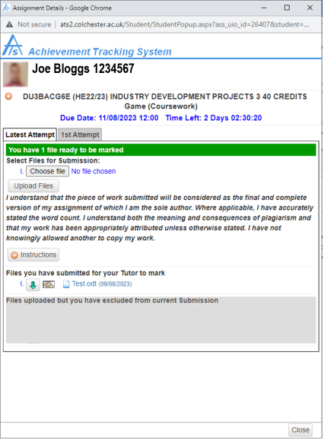
- Plagiarism Check (URKUND)
- When you submit your work into ATS2, it automatically completes a plagiarism check and you will see a colour coded number of the % of work considered to be similar to existing work available. If you wish to explore this further you can click on the number which will share further information.
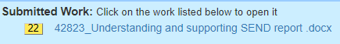
If you are in any doubt please ask your course tutor.

- If you change your mind and wish to submit the file you previously omitted, simply click the up arrow next to the file and it will be moved into the marking area.

- Once you have finished with your upload click close on the bottom right-hand corner.

Accessing Your Grades and Feedback on ATS2

- You will receive an email to advise you when your grades have been released with a link.

- Alternatively, you can follow the instructions provided at the start of this document to access you personalised ATS2 assessment page which will contain all your assignments for the current and previous years if you are a returning student.

- The example below is how your page will appear. This is also where you can see your grades once your assignments are marked:

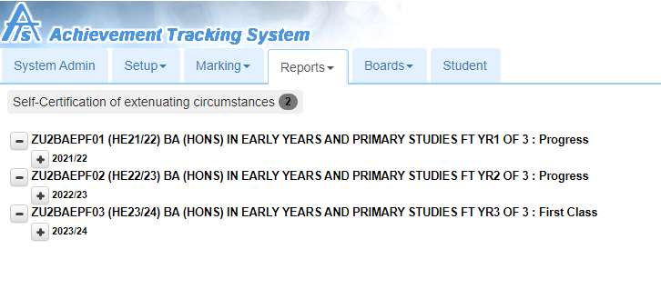Click on the + symbol to see your submissions:
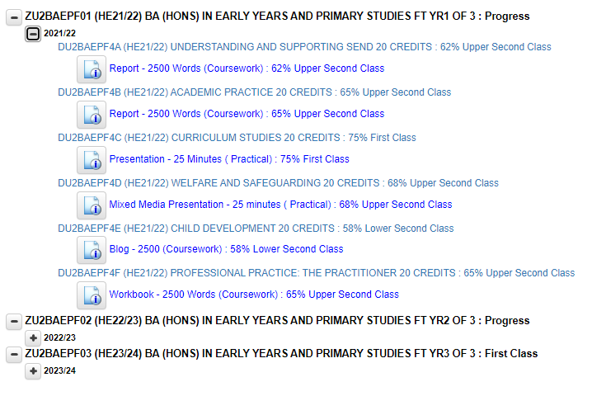Then click on the icon to view your results (you can see your submitted file and the feedback files). In this example there is an annotated copy of the work and the grade sheet:



